**OPTIMUM SUGAR SYRUP FEEDING INTERVALS FOR *Apis Cerana* Fab. DURING THE WINTER DEARTH PERIOD IN THE SUB-TROPICAL AREA OF NEPAL**

**Supplementary Data:**

Figure 1. Trend line graph of sealed honey area for all tested treatments.

Figure 2. Trend line graph of number of eggs laying by queen bee for all tested treatments.

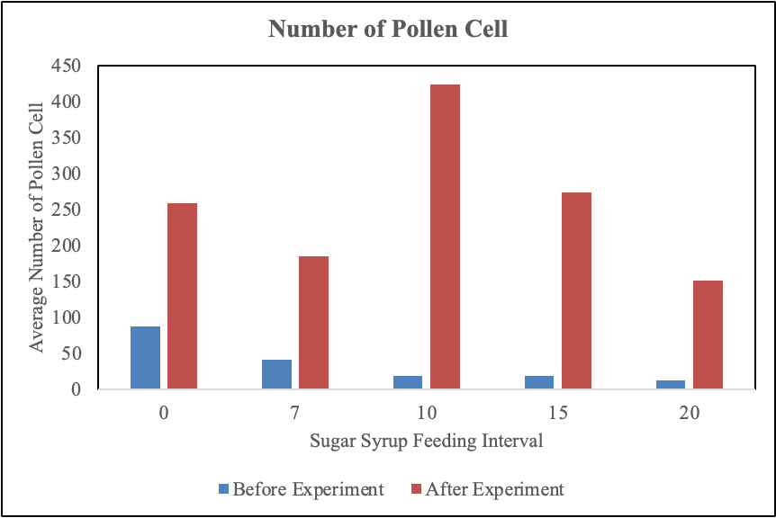

Figure 3. Effect of different feeding intervals on the number of pollen cells